hey coree, when you get back, I need to know a few things for the sharepoint application - osv tracker list

if you go to https://entra.microsoft.com/

It will take you to the page where it has the ZT Systems tenant ID and other info

what i need is the APP registration ID
- Go to Shortcuts section 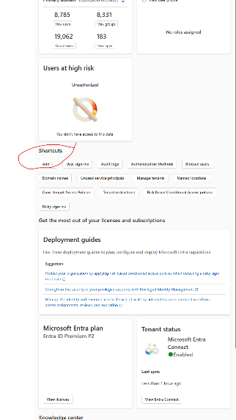click on the add drop down and select App Reg
- fine the OSV Tracker List app and its going to give you a page that should look like this
I need all that infor for the automatic entires update

